6A^{th} Grade: Unit 5, Lesson 6
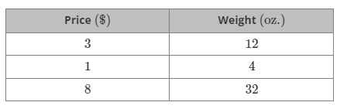
- The table shows equivalent ratios of the price, in dollars ($), for blackberries and their weight, in ounces (oz).
What number can be multiplied by each value in the first column to get the value shown in the second column?
4

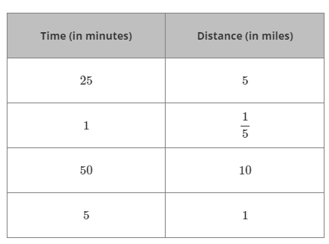
- A table representing the distance Donna rides her bike, in miles, and the time it takes her, in minutes, is shown.
Based on the table, how many miles will Donna travel after riding her bike for 75 minutes?
15

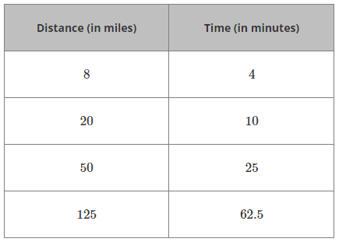
- The table represents the distance traveled by a helicopter, in miles, over different periods of time, in minutes.
The same factor was multiplied by the values in each row to determine the values in the next row. What factor was used?
2.5

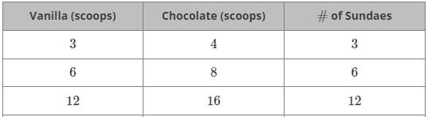
- The ratio of vanilla to chocolate ice cream, to make a specific number of sundaes, is displayed in the table below.
If there were 21 Vanilla scoops, how many Chocolate scoops would there be?

28 scoops

- It take 4 cups of sugar and 3 cups of cream to make 1 gallon of ice cream. How many cups of sugar will it take to make 3 gallons of ice cream?

12 cups

- A specific color of paint requires a certain amount of red and blue paint to mix. The number of cups needed for each color are displayed in the table below.
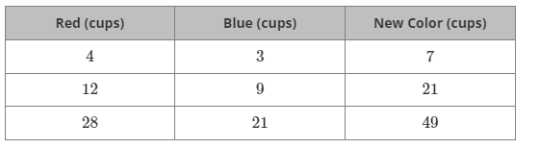
If 20 cups of red paint are needed to make 35 cups of the new color paint, how many cups of blue paint will be needed?
15 cups

